Fashion Show for Down Syndrome Ireland at the Radisson
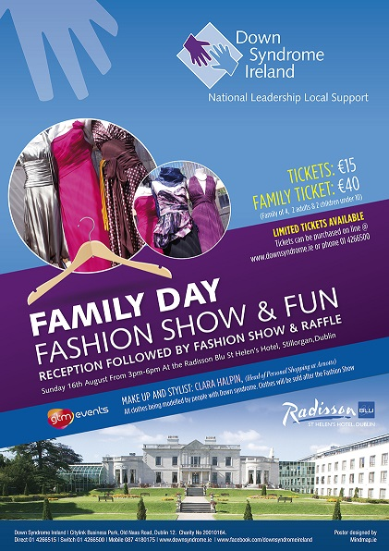
Down Syndrome Ireland will be having a fashion show on the 16th of August 2015 at the Radisson Blu St. Helen’s Hotel in Stillorgan from 3pm to 6pm. All the models are people with Down syndrome and they will take to the catwalk for a day packed with fashion and style.
Kathleen Fitzsimons who works for Down Syndrome Ireland said: “I have seen them training and I am so impressed with their confidence and personalities. It is a hive of activity with sourcing the clothes, fitting them and training on the cat walk, it is all so rewarding and fun. Clara Halpin (Head of Personal Shopping at Arnotts) and Niamh Ryder is being a huge support with looking after the training and the make-up and styling on the 16th August.”
For those of you who are not familiar with Down syndrome, it is a chromosomal anomaly caused by an error in cell division that results in the presence of an additional third chromosome 21 or “trisomy 21”.
“People with Down syndrome, whatever their age, are people first. They are people with abilities, strengths and weaknesses like everyone else. They may have additional needs but people with Down syndrome all over the world now lead full and independent lives. The quality of health care, education and community support provided to children and adults with Down syndrome makes a real difference to their quality of life,” Down Syndrome Ireland.
Down Syndrome Ireland is dedicated to being Ireland’s primary source of expertise, support and information to people with Down syndrome, their families and the professional community. We are working to achieve an optimal quality of life for people with Down syndrome, as equally valued and independent citizens.

Down Syndrome Ireland was set up in 1971 by a small group of parents. We are now a national organisation with 25 branches and over 3,500 families. These are run on a voluntary basis by our family members.

The show will help to illustrate the potential of young people with Down Syndrome, to not be the subject of pity but to be respected as peers in a society that can be at times far too presumptuous.
Tickets cost €15 or €40 for a family of 4 (2 adults and 2 children under 10) and can be purchased on line at www.downsyndrome.ie or call 01 4266500. Stick around for a clothing sale, reception and a raffle afterwards! There is limited availability for these tickets so be sure to get yours early!

www.downsyndrome.ie

